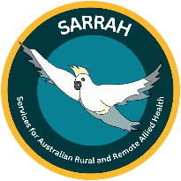
Services for Rural and Remote Allied Health
The Allied Health Rural Generalist Education and Training Scheme (TAHRGETS) evaluation outcomes: Policy brief

Introduction:
Disparities in health outcomes between rural and urban populations in Australia are a long-standing issue. Recruitment and retention challenges and workforce maldistribution of allied health professionals, such as speech pathologists, dietitians, physiotherapists and psychologists, contributes to inequities in healthcare access for rural and remote communities.
The Allied Health Rural Generalist Training and Education Scheme (TAHRGETS) was funded by the Australian Department of Health, Disability and Ageing (DHDA) between September 2021 and December 2025. TAHRGETS provided funding for up to 90 training packages to support Allied Health Rural Generalist (AHRG) Training Positions in private and non-government services in Modified Monash Model (MMM) 3 to 7 locations. Flinders University completed a mixed-methods research study to evaluate the TAHRGETS scheme against the objectives and outcomes outlined in the grant agreement, and to look at elements of program design that worked well and could be improved. Funding for the evaluation was provided by DHDA.
Background:
Rural Generalists are health professionals trained to work across a broad range of clinical presentations, age groups, and settings, with specialised skills tailored to meet the unique needs of rural and remote communities. Rural generalists work within the scope of practice and regulatory instruments of their profession and the policies of their employer.
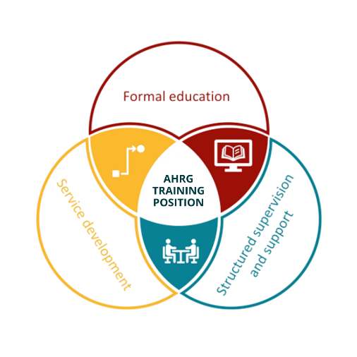
The Allied Health Rural Generalist Pathway (the Pathway) is a workforce, service and education strategy to increase access to a skilled allied health workforce for rural and remote communities.
The outcomes of Allied Health Rural Generalist Training and Education Scheme (TAHRGETS) agreed with DHDA were to:
- Provide support to private and not for profit service providers, to build capacity and expand allied health service delivery in rural and remote locations.
- Increase the number of allied health rural generalists in rural and remote locations as well as practices offering greater access through an extended range of services.
- Develop career pathways and improve the retention of allied health professionals working in rural and remote areas.
Figure 1. Elements of an AHRG Training Position
Training packages enabled workplaces to support the direct costs of AHRG Training Positions and offset the organisational impact of their mandatory work time allocation to training, service development projects and workplace supervision. TAHRGETS resourcing included funding for trainees’ post-graduate tuition fees, a workplace training grant to the employer, plus program coordination/administration, and training site coaching and support provided by the SARRAH team.
DHDA grant guidelines for TAHRGETS assigned 30 training packages for Aboriginal Community-controlled Health Organisations (ACCHOs), and 60 packages for mainstream services.
Evaluation of TAHRGETS:
Flinders University was contracted to deliver a robust, external evaluation of the implementation, impact and outcomes of the TAHRGETS. The study used a mixed methods approach with a data collection period between January 2022 to October 2024. The evaluation included 53 semi-structured interviews with trainees (current, withdrawn), and managers and supervisors, case studies, Discrete Choice Experiment survey with stakeholders who had not participated in the strategy, and analysis of implementation data.
TAHRGETS outputs and outcomes:
- Sixty-two (62) early career AHPs were employed in AHRG Training Positions and were supported by the TAHRGETS. Participants were from nine different professions and all states and territories except Victoria and the ACT. Of these participants:
  - 60 were in mainstream providers (implementation target fully achieved) and two were in ACCHOs (implementation target not achieved), and
  - 37 had completed or were projected to complete their training by December 2025. A withdrawal rate of 40% was broadly consistent with published data from the South Australian public health service AHRG Training Positions (46.6%) and Queensland Health Medical Rural Generalist Pathway (36.3%). Of the 25 withdrawals, 15 were due to changes in employment and 10 due to personal reasons.
- Seventeen (17) AHPs were recruited to new training positions created in their organisations with the support of the TAHRGETS packages. The evaluation study estimated these new positions contributed more than 42,000 service hours to their communities over the two-year duration of the program, even when training demands were considered. The remaining trainees occupied existing positions in their organisation.
- TAHRGETS showed early signs of benefitting retention, with all completing trainees indicating good intention to stay (2-5 years); however, longer follow-up would be required to better understand this.
- Stakeholders identified that trainees improved their ability to manage clinical complexity, solve problems and apply evidence-based practice to local healthcare challenges.
- Forty-seven (47) service development projects were undertaken in TAHRGETS sites, which provided learning and capacity building for trainees and teams, and produced tangible improvements for service providers and their clients. These included new and expanded local services, quality improvements and new models of care e.g. new falls prevention program, expansion of a medication review service in the region, training packages developed for families and support workers, a business framework for employment of allied health assistants in private practice.
Key Challenges:
- TAHRGETS program implementation was challenged by long-standing rural workforce shortages, with subsequent impact on recruitment, retention and completion rates.
- The AHRG Pathway is a relatively new concept for the private and non-government sector, with further engagement, education and promotion required to realise potential benefits of the strategy.
- Short-term grant timeframes and restrictive funding rules conflicted with workforce realities in rural and remote areas, particularly recruitment delays and trainee transfer/turnover due to personal reasons. Improved capacity to transfer funding packages between trainees in an organisation and to follow a trainee who transfers between rural locations or providers would have likely improved completion rates.
- Extensive engagement with the First Nations health sector to better understand the limited uptake of TAHRGETS in this sector identified that just one of the 18 ACCHOs consulted was employing a full team of allied health staff. ACCHOs reported short-term funding streams impeded the establishment of positions. Most organisations delivered allied health services through contracted workers, making them ineligible for TAHRGETS. Changes to system-level impediments to the employment of allied health teams in ACCHOs would be required to progress AHRG Training Positions in this sector.
Key messages:
- Private and non-government organisations need support to develop a sustainable and fit-for-purpose rural and remote allied health workforce. This includes financial support to enable workplace-based training and clinical supervision of early career rural generalist practitioners across a range of allied health professions, as well as support to build rural generalist workforce capacity.
- TAHRGETS was effective at supporting the development of rural generalist training capacity, infrastructure and systems in mainstream private and non-government allied health service settings, and for a wide range of professions.
- TAHRGETS was effective in enhancing the skills and knowledge of AHPs, thus improving the capacity and quality of the rural and remote allied health workforce.
Implications for policy makers:
- Australian Government funding for TAHRGETS and creation of a National AHRG Pathway concludes in December 2025. Positive evaluation findings indicate further policy and funding measures for the AHRG Pathway can produce benefits for service providers, funders and the community.
- The AHRG Pathway aligns with the objectives of the National Allied Health Workforce Strategy (Australian Government 2025), in draft at the time of writing. The Strategy will outline how to better align the supply and distribution of allied health professionals with current and future needs. TAHRGETS has demonstrated success in this objective and program expansion is recommended.
- Allied Health Rural Generalist Training Positions demonstrate a promising contribution to rural career pathways and workforce sustainability. However, formal recognition mechanisms for allied health rural generalists do not yet exist. Opportunities for career advancement, recognition of advanced or expert skills sets, and financial incentives for rural generalist practitioners, may improve retention and training completion rates.
Further Information:
Further information on the TAHRGETS is available here.
Further details of the TAHRGETS evaluation are published in the report.
For additional information or inquires please contact SARRAH at sarrah@sarrah.org.au

Cleland J, Milte R, Khanna D, George S, Brebner C, Campbell N, Tuxworth G, Maloney C, Worley P, Dymmott A. Recruitment, retention and turnover of allied health professionals in rural and remote areas: a quantitative scoping review. Rural and Remote Health 2025; 25:9494. https://doi.org/10.22605/RRH9494
O'Sullivan BG, Worley P. Setting priorities for rural allied health in Australia: a scoping review. Rural and Remote Health. 2020; 20(2): 5719. DOI: 10.22605/RRH5719
Dymmott A, Brebner C, George S, Campbell N, May J, Gill R, et al. The allied health rural generalist pathway: a cost consequence analysis. Rural Remote Health. 2024 Jun; 24(2): 8557. DOI: 10.22605/RRH8557
Sen Gupta T, Manahan D, Lennox D, Taylor N, Stewart, R, Telfer J, et al. The Queensland Health Rural Generalist Pathway: Demonstrable Impacts on Rural Medical Workforce. Proceedings of the 13th National Rural Health Conference; 2015 May 24-27; Darwin, NT. Available: http://www.ruralhealth.org.au/13nrhc/images/B1_Tarun_Sen_Gupta.pdf

